July / August 2020

CHILE
Blinded by police: Gustavo needs justice!

Your eyesight allows you to read this sentence. That’s something Gustavo Gatica can’t do anymore.

Last year, he was a student at a university in the capital city, Santiago. While he was in his psychology classes, Gustavo knew that people all over the country were grumbling about the increase in bus, subway and train tickets. The prices of other items had already gone up, so some just couldn’t pay for more.
Gustavo Gatica before he was struck with buckshot
©Amnesty International

The grumbles turned into protests. On November 8, he went to one of the huge demonstrations.

Police were there. They had loaded their guns with buckshots. Those are pellets coated with rubber. Buckshot is dangerous enough that world standards do not allow their use by police. When police fired into the crowd, their buckshots hit many protestors and injured them badly. No police commander stopped the shooting.

Buckshots struck Gustavo in both eyes and he suddenly went blind.

Police commanders later investigated what happened to Gustavo but they decided that no officer could be blamed. Well that’s not right. They should not have been using buckshot at all. And they should at least apologize to Gustavo and make up for the damages they caused to him.

Gustavo’s case became famous in Chile because he didn’t just suffer bruises or broken bones; he lost his eyesight. If we can get justice for him, it will be easier to get justice for the others who were also injured.

There’s something else our letters will do. They will help to make sure that police commanders obey the limits of their powers and make sure the police act properly in the future.

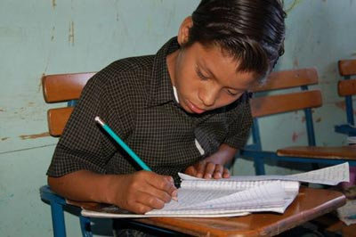
WHAT CAN I DO?

Please write to the Attorney General. Because Canada Post is not delivering mail to Chile during the pandemic, either mail your letter via the embassy or contact him directly by email or social media.

- Start your letter with Dear Attorney General.
- In your first sentence, tell him what you study at school. This makes your letter different from the others he will receive.
- In your second sentence, describe your concern about what happened to Gustavo Gatica.
- In your last sentence, ask him to examine how police commanders failed to stop the violence so that it never happens again.

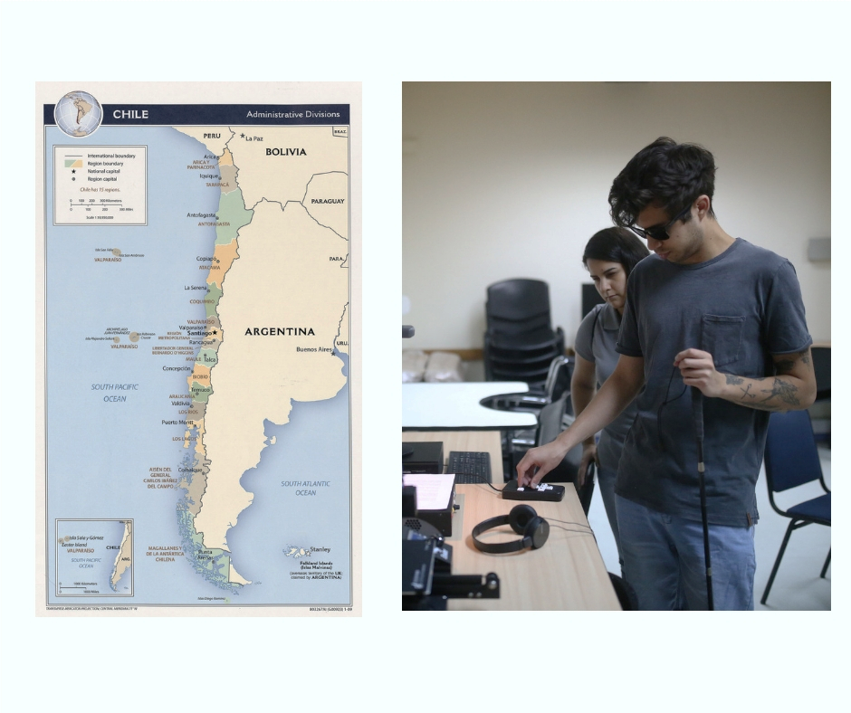
WHERE DO I SEND MY MESSAGE?

Jorge Abbott Charme
Fiscalía Nacional
Embassy for the Republic of Chile
50 O'Connor Street, Suite 1413
Ottawa, Ontario K1P 6L2

Postage: $.92 stamp
Email: jabbott@minpublico.cl
Twitter: @FiscaliadeChile
Instagram: @fiscaliadechile
Facebook: https://www.facebook.com/pages/Fiscal%C3%ADa%20Nacional/345649492241585/

Gustavo learns about audio tools to make up for his loss
of sight © Edgard Garrido
Map of Chile

WHAT ELSE CAN I DO?

Because Gustavo can’t see, you could record a greeting in Spanish or English with your name, country and something like Te apoyo, Gustavo (I support you, Gustavo) or Te envío los mejores deseos de Canadá (I send best wishes from Canada). Email it to justiciaparagustavo@amnistia.cl.

Or you could mail a greeting with international postage to
Gustavo Gatica, Amnistía Internacional Chile
Calle Eliodoro Yañez 828, Comuna de Providencia
Santiago de Chile
This type of message should be something he can feel. How about cutting letters or maybe a maple leaf out of a fuzzy or fluffy material and pasting them onto paper or cloth? Or make something out of origami. Or you could create a design or message using Puffy 3D Paint.

If you have not received this Lifesaver directly from Amnesty International’s Toronto office
and would like future actions, reach us at the contact information in the header. There is no cost.

