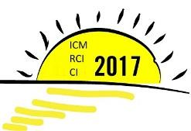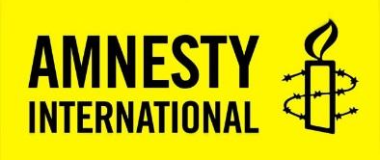

Amnesty International members only
33rd International Council Meeting
Circular 1: PrepCom’s ambitions and call for Working Party Facilitators

AI Index: ORG 50/4883/2016
To: Sections and structures
ICM Session: N/A
From: 2017 International Council Meeting Preparatory Committee
Date: 7 October, 2016

PURPOSE STATEMENT
- This is the first circular for the 2017 International Council Meeting (ICM), which will be held on 11-15 August 2017. The location and venue of the ICM will be confirmed at the end of the 2016.
- This circular includes a welcome letter from the ICM Chair and Alternate Chair
- It also includes a call for nominations for Working Party Facilitators. We are looking for people within the movement who have proven experience as group facilitators and who will contribute to a participatory experience in the working parties. A nominations form for this position accompanies this circular (appendix 1).

DISTRIBUTION
- This paper is for section and structure chairs, board members and directors.
- Please consult with your board, members and staff on the contents of this paper.
- If this is your first ICM, please visit the ICM webpage “Your Guide to the ICM” to help you prepare for the meeting.

DEADLINES
- Nominations for Working Party Facilitators must be made by the nominating section or structure chair or director.
- The chair or director must complete Part 1 of the Nominations Form (appendix 1) and then return it to the Governance Programme at ICM@amnesty.org by the deadline of 14 November, 2016.

Contents page

Part 1: Welcome to the 33rd ICM: 2017 ICM Preparatory Committee ambitions and call for Working Party Facilitators 3
Part 2: What is the PrepCom and what is its role? 4
Part 3: Call for ICM Working Party Facilitators 4
Working Party Facilitator Job Description 6
APPENDIX 1: 2015 ICM WORKING PARTY FACILITATOR NOMINATIONS FORM 8

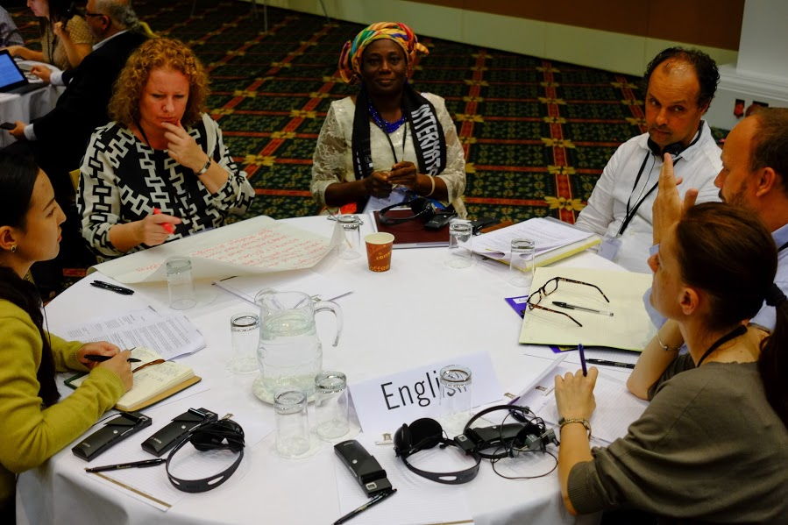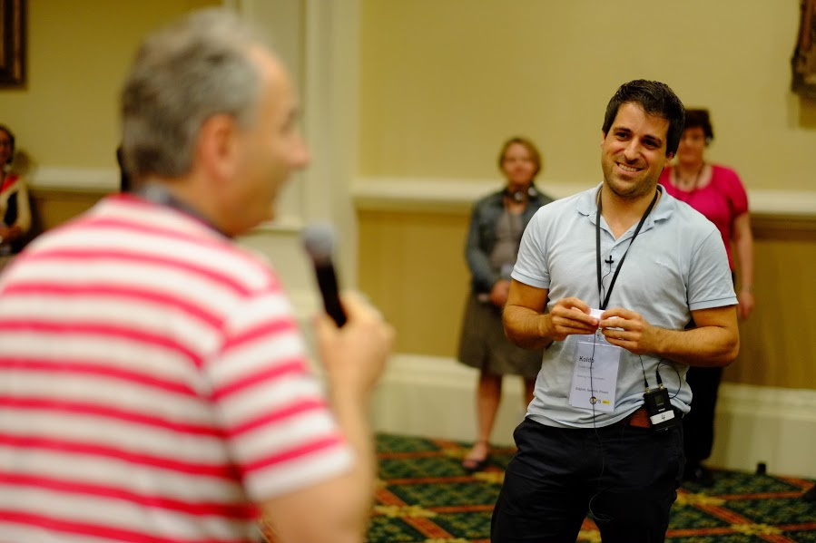
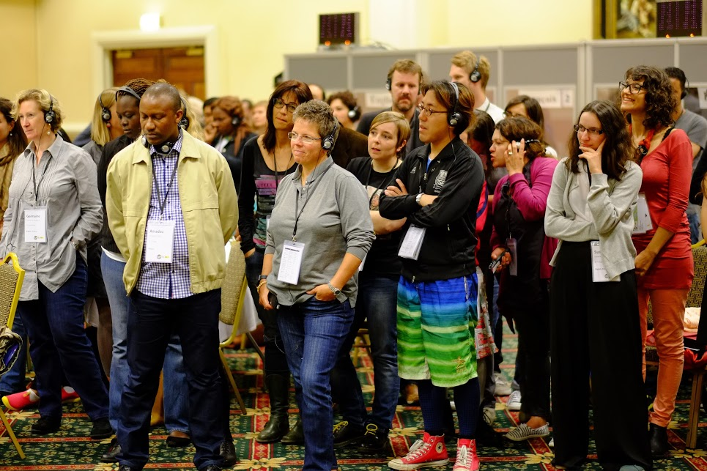
Part 1: Welcome to the 33rd ICM: 2017 ICM Preparatory Committee ambitions and call for Working Party Facilitators

Dear friends,

The planning of the 2017 International Council Meeting (ICM) has begun. As the new ICM Chair and Alternate Chair, elected by you in 2015, we are very excited to finally take up the roles of facilitating the meeting of Amnesty’s highest decision-making body. As we mentioned in our previous communications, and already practiced at the 2016 Chairs Assembly and Directors Forum (CADF), Koldo and I will work in close partnership in facilitating the 2017 ICM. In this first circular, we share with you our ambitions for the international meeting, some advice on selecting your delegation, and also ask for your help in finding facilitators who will allow us to have inclusive, participatory and engaging conversations together in August.

As our highest decision-making body, our primary ambition is for the ICM to be focused on what drives our movement: our passion for human rights. 2017 will mark the second year of the implementation of the Strategic Goals, which we all committed to because we accept that our strategy must increase our ability to achieve real human rights impact. The meeting will include an initial assessment of how we are performing against the Goals, and the PrepCom will ensure that human rights impact will guide all our conversations at the 2017 ICM.

We know that to achieve the Goals we need to organise our governance differently, so that we can make informed decisions more quickly. This meeting will be the culmination of work we have done on reforming our governance model, as mandated by Decision 7 of 2013 ICM. Over the past three years the movement has been engaged in numerous, thorough consultations and discussions on how we can reform our governance to be more effective, streamlined and to achieve greater human rights impact. Our ambition for the 2017 ICM is a meeting which will honour our commitment to change, where we will come together and take decisions that will make us a stronger human rights movement.

Many of us came together at the 2016 CADF and that meeting gave us an excellent opportunity to think about how we have our conversations. We are committed to creating spaces for discussions that are participatory, inclusive and allow you to hear from your peers from different regions: active participation is key to making the best decisions for our global movement. We also aim to strike the best possible balance considering the constraints of interpretation, your desire to share your opinions with the full Council, as well as having in-depth conversations in small groups. As always we welcome any feedback from you about how to make our meetings more diverse and inclusive and invite you to email us at PrepCom@amnesty.org.

We know from personal experience that preparing for the ICM can be a difficult task where you have to manage lots of information. For this reason, we also commit to sharing key ICM preparation dates, draft agendas and the papers list with you in advance. Please use this information to plan the dates of your AGM, board meetings and the preparatory meetings of your ICM delegation. As a chair or director it is your responsibility to ensure delegates elected or nominated to participate in the ICM understand the key discussion topics and are able to actively participate in our conversations. If this is your first ICM, please visit the ICM webpage “Your Guide to the ICM” to help you prepare for the meeting.

Diversity was an important conversation for us all at the 2016 CADF, particularly in the discussion on Governance Reform and the conversations on Strategic Goal 5. As you begin selecting your ICM delegations, please remember that your delegation should be reflective of our aspiration to be a truly global human rights movement. We strongly encourage you to select a diverse ICM delegation, with adequate representation of genders and the inclusion of young people.

The ICM will take place on 11-15 August and we will have workshops for youth delegates, chairs and first time participants before the official start of the meeting. In March 2017 we will share a draft of the agenda confirming the meeting’s duration and schedule.

Finally, we need your help to find facilitators for the ICM. The ICM is a big meeting with various topics for discussion. Our role as PrepCom is to facilitate inclusive discussions where all delegates’ voices are heard. To enable this, we split the topics for discussion into smaller groups, called working parties. We are still deciding what the topics of each working party will be, but in the meantime we invite you to nominate qualified and experienced individuals for the role of Working Party Facilitators by 14 November. We hope that you can help us find people within the movement who have proven experience as group facilitators. Please see Parts 2 & 3 of this circular for more information.

Best wishes,
Christine Pamp (2017 ICM Chair) & Koldo Casla (2017 ICM Alternate Chair),
2017 PrepCom

Your next steps…
- Start thinking about your ICM delegation, remembering the need for diversity;
- Send us nominations for Working Party Facilitators (see below for more information);
- In mid-November we will share the “Preparing for key conversations” circular, which will include the template, deadline and process for submitting resolutions and information on how we will deal with Statute changes.

Part 2: What is the PrepCom and what is its role?

The ICM PrepCom is an independent committee whose members are: the Chair and Alternate Chair of the ICM (elected by the preceding ICM); the appointed Working Party Facilitators; a member of the International Board and a representative of the Secretary General. Its term of office runs from the appointment of the working party chairpersons, until the appointment of working party chairpersons for the next International Council.
The role of the committee is to ensure the efficient preparation of the ICM so that the meeting, and in particular the working party discussions, are inclusive, participatory and encourage participants to own the decision-making process. The Committee is also responsible for ensuring that the discussions that take place at the ICM are the correct ones for the top strategic leadership of Amnesty International.
For more information on the PrepCom, please visit the ICM website: click here.

Part 3: Call for ICM Working Party Facilitators
The delegates of the International Council (IC) are divided into smaller discussion groups called working parties. Working party discussions are a key part of our democratic decision-making process, and their outcomes will shape the future of Amnesty International. Being a Working Party Facilitator is a challenging but rewarding role. Over 65 countries are represented at the ICM and the role of the facilitators is to enable qualitative conversations across the diverse cultures of our movement.

What is an ICM Working Party Facilitator and what do they do?
The role of a Working Party Facilitator is to organise and contribute towards inclusive and participatory working party discussions. As a result, everyone’s voice is heard and the working party comes to the best decision for Amnesty as a global movement. The facilitator is supported in the working party by a secretary and administration assistant. The decision on the topics and number of working parties will be taken in January.

What skills do I need to be a Working Party Facilitator?
- Experience as an inclusive facilitator in large groups (approximately 100 people);
- Confidence in facilitating complex debates in a participatory way and ideally across cultures;
- Ability to ensure that all participants feel empowered;
- Patience and ability to build consensus;
- Strong leadership and organisational skills, with the flexibility to change methodologies if necessary;
- Ability to work in English (the working language of PrepCom). Additionally, we are looking for a facilitator who is fluent in French;
- Ability to work as part of a team;
- Familiar with the debates and workings of Amnesty International, while being able to maintain neutrality on these topics.

Who can be a Working Party Facilitator?
- Anyone affiliated with an Amnesty International section or structure (member, board member, activist, staff member). Facilitators cannot be part of their ICM delegation, for this reason chairs or directors should not nominate themselves for this role.
- This role is funded by the international budget.
- Your nomination must be supported and submitted by your section or structure chair or director.
- You must be able to make the time commitment required. See “Detailed information” below.

How do I apply?
Accompanying this circular you will find a Nomination Form (appendix 1). This should be completed by the person applying for the position. S/he should then send the form to the section or structure chair or director, who must complete ‘Part 1’ of the form and send it to the Governance Programme (icm@amnesty.org) by 14 November, 2016.

Detailed information on the role
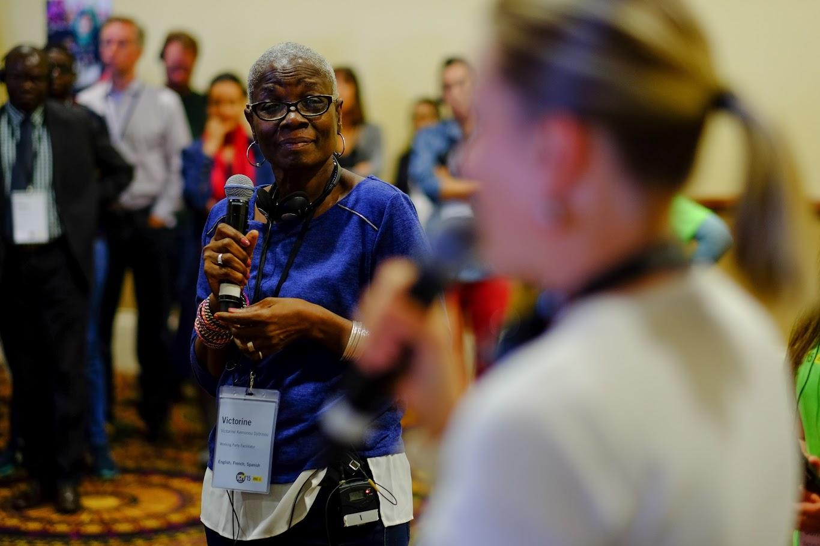
What is the time commitment?
PrepCom meets primarily via videoconference, with one face to face meeting in February. You must be able to make the time commitment as stated below:

5 December: 60 minute videoconference
21 January: 2 hour video conference
Mid-February: 2 day face to face meeting
9 – 16 August: participation in the ICM.
You will also need to allocate time for ad-hoc video conferences, responding to emails, reading, and liaising with sections.

Important: An initial pool of facilitators will be selected in November and required to participate in a videoconference week commencing 5 December. The decision on the topics and number of working parties will be taken in January. All candidates must be available for a videoconference on 21 January.

Working Party Facilitator Job Description
Job Title: | Working Party Facilitator
Reports to: | ICM Chair
Supported by: | Working Party Secretary and Working Party Administration Assistant
Overall Purpose of Job: | To facilitate participatory, inclusive and quality decision-making in sessions of a Working Party during the ICM.
Primary Tasks: | 1. Facilitate all sessions of your Working Party in an inclusive, participatory way that maximises the active engagement of all participants across a variety of cultures. This may include agreeing ways forward for difficult decisions.  2. Prepare for discussions on the areas of your Working Party by:  - Briefing yourself and following discussions on the topic to be assigned to your Working Party;  - Engaging with resolutions, including pre-ICM communications with sections and structures (for instance to combine resolutions where appropriate, and ensure revised text is supplied to PrepCom by the stated deadline).  3. Participate in PrepCom meetings and video conferences before the ICM to discuss resolutions, draw up the ICM agenda, agree approaches to discussions and the distribution of Working Party discussions.  4. Participate as an active member of PrepCom (including adhering to the agreed timelines and attending all meetings of the Steering Committee during the ICM) and acting as the liaison point for the Working Party.  5. Agree, together with the Working Party secretary, how to report back from the Working Party to the ICM plenary and represent the Working Party as needed in the plenary (including in relation to amendments to resolutions discussed in his/her Working Party).  6. Support the ICM Chair, including by advising on discussions and decisions from your Working Party.  7. Support the Working Party Secretary with the production of your Working Party Report and present this report to the plenary.
Additional Tasks: | - Ensure all participants of the Working Party have a chance to meet and be introduced to each other.  - Check-in with Working Party participants as needed to ensure all concerns are being covered and that everyone has a chance to participate fully in group discussions.  - Help run training sessions on the ICM for new participants;  - Facilitate other sessions of the ICM, such as workshops or discussions, as assigned by the ICM Chair.

APPENDIX 1: 2015 ICM WORKING PARTY FACILITATOR NOMINATIONS FORM

Candidates should complete this Nominations Form before sending it on to their section / structure chair or director. The chair / director must complete ‘Part 1’ and then forward the form to the Governance Programme at ICM@amnesty.org by 14 November, 2016.

PART 1: NOMINATING SECTION/STRUCTURE

Section/structure name:

Chair / director name (please indicate whether you are the chair or director):

Tel:

E-mail:

PART 2: CANDIDATE INFORMATION
Surname:

First name:

Address:

Tel:

E-mail:

LANGUAGE SKILLS
Please highlight as appropriate
w = written / s = spoken

 | NATIVE SPEAKER | FLUENT | INTERMEDIATE | BASIC
English | w s | w s | w s | w s
French | w s | w s | w s | w s
Spanish | w s | w s | w s | w s
Other, please specify : | w s | w s | w s | w s

Please keep your answers in this section brief.

FACILITATION EXPERIENCE
We are looking for people with proven experience as group facilitators who will create a participatory experience for meeting delegates. Please provide examples of your facilitation experience using the headings below, indicating the type of meetings and group size.

- Experience facilitating complex debates in a participatory way:
- Experience working across a variety of cultures:
- Ensuring all meeting participants are actively involved and empowered during the discussion:
- Managing conflict and resistance during group discussions while maintaining neutrality:

AMNESTY INTERNATIONAL EXPERIENCE
Please indicate the roles you have held within your section / structure:

ICM EXPERIENCE
Please indicate your level of ICM experience (previous ICMs attended, your role at the ICM or as part of your delegation)

FAMILIARITY WITH THE CURRENT DEBATES IN AMNESTY INTERNATIONAL
Although we have not yet decided the topics of the working parties, we would like to know more about the areas in which you have experience with Amnesty International’s current debates. Please provide information on your experience in the following areas. Your answers should be brief but thorough.

EXPERIENCE / EXPERTISE
Human Rights Policy/Strategy
Governance (in particular Governance Reform)
Policy development
Strategic Goals (overall and specifically Goals 1- 4)
Growth and Fundraising
Finance

Important: An initial pool of facilitators will be selected in November and required to participate in a videoconference week commencing 5 December. However, the decision on the topics and number of working parties will be taken in January. All candidates must be available to participate in a videoconference on 21 January.

ORG 53/006/2013: 2013 ICM Decisions Report

