URGENT ACTION
FORCIBLY RETURNED ACTIVIST HELD INCOMMUNICADO
Dong Guangping’s court hearing scheduled for April 2017 has been cancelled by authorities with no reason provided. Charged with “subverting state power” and “crossing the national border illegally”, Dong Guangping has been held incommunicado since his forced return from Thailand in 2015. He is at risk of torture and unfair trial.
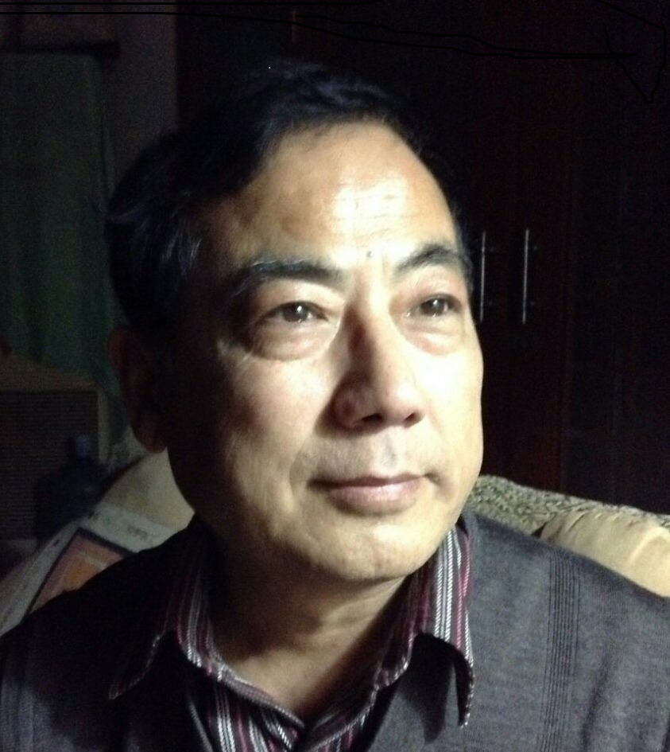
In contradiction with Chinese and international law, Dong Guangping continues to be denied access to a lawyer of his choice. The government appointed lawyer, who in August 2016 replaced the one hired by Dong Guangping’s family, quit on 14 July 2017 due to difficulties in handling the case. While he had originally passed information to the family about Dong Guangping’s indictment and the scheduled date of the trial, he failed to provide further updates after the government cancelled the court hearing scheduled for April 2017.
Dong Guangping’s lawyer, who had first been appointed by his family, again visited the detention centre in Chongqing on 24 July 2017. The detention centre, which has repeatedly rejected the lawyer’s requests to meet him, stated Dong Guangping would defend himself in court and not employ any lawyer. As the lawyer’s request to confirm this with Dong Guangping personally was refused, this assertion was unable to be independently verified. As the authorities do not recognize the family appointed lawyer as legitimate, he was unable to review the indictment or any document the government has filed against Dong Guangping to date.
Accepted for rapid resettlement, Dong Guangping was forcibly returned to China on 13 November 2015, five days before he was scheduled to depart from Thailand to a third country. Dong Guangping has now been detained for more than 20 months and his family have yet to receive direct notification from authorities about his whereabouts, arrest, indictment or charges against him. With no access to his family or a lawyer of his choice, Dong Guangping is at risk of torture and unfair trial.
1) TAKE ACTION
Write a letter, send an email, call, fax or tweet:
- Ensure that Dong Guangping is tried in line with international fair trial standards and not for the peaceful exercise of his human rights;
- Ensure that while in detention Dong Guangping is not subjected to torture or other ill-treatment, has regular, unrestricted access to his family, lawyers of his choice, and medical care on request or as necessary;
- Cease requesting other countries return individuals to China in violation of international law.

Contact these two officials by 19 September, 2017:

Director of Chongqing Municipal No.2 Detention Centre
Chongqing Shi Dier Kanshousuo
6 Shengan Lu
Fusheng Zhen
Jiangbei Qu
Chongqing Shi 401133
People’s Republic of China
Salutation: Dear Director

Ambassador Tiankai Cui, Embassy of the People's Republic of China
3505 International Place NW,
Washington DC 20008
Fax: 1 202 495 2138
Phone: 1 202 495 2000
Email: chinaembpress_us@mfa.gov.cn
(If you receive an error message, please try calling instead!)
Salutation: Dear Ambassador

2) LET US KNOW YOU TOOK ACTION
Click here to let us know if you took action on this case! This is Urgent Action 259.15
Here's why it is so important to report your actions: we record the actions taken on each case—letters, emails, calls and tweets—and use that information in our advocacy.

URGENT ACTION
FORCIBLY RETURNED ACTIVIST HELD INCOMMUNICADO

ADditional Information
Dong Guangping was a policeman in China. His employment was terminated in 1999 after co-signing a public letter and distributing articles in different cities commemorating the 10th anniversary of the 1989 Tiananmen Square crackdown. He had previous been detained in China several times for his peaceful activism. He was imprisoned for 3 years in 2001 for “inciting subversion of state power” and was detained by Chinese authorities from May 2014 to February 2015 after participating in an event commemorating victims of the 1989 Tiananmen Square crackdown. He arrived in Thailand with his wife and daughter in September 2015 to escape harassment.
When the Thai government forcibly returned Dong Guangping and another activist Jiang Yefei to China on 13 November 2015, they had already been accepted for rapid resettlement in a third country and were scheduled to depart on 18 November. The UNHCR and the Office of the UN High Commissioner for Human Rights (OHCHR) voiced strong concern about the forced return of Jiang Yefei and Dong Guangping and their risk of torture and other ill-treatment.
The two men were seen on 26 November 2015 on state media news agency CCTV “confessing” to human-trafficking offences and “admitting” that Jiang Yefei had assisted Dong Guangping to cross the border “illegally” into Thailand. After viewing the footage, their families raised the allegation that both men may have been subjected to torture or other ill-treatment. They found that the two men’s facial expressions and tone of voice were suspiciously different from usual, and showed signs of pain and stress.
South East Asian countries are increasingly violating the non-refoulement principle following pressure from the Chinese government. This principle prohibits the transfer of people to any country or jurisdiction where they would be at risk of serious human rights violations or abuses. It is enshrined in numerous international instruments, and has achieved the status of customary international law, binding on all states regardless of whether they have ratified the relevant treaties, such as the UN Refugee Convention, the International Covenant on Civil and Political Rights, or the Convention against Torture and Other Cruel, Inhuman or Degrading Treatment or Punishment.
The criminal justice system in China is roughly divided into three distinct phases: the investigation phase conducted by the police; the prosecution phase, in which the prosecutors approve of the initial evidence needed to arrest a suspect and engages in further investigation to decide whether to indict a suspect; and the final trial phase carried out by the courts.

In China, defendants are almost always found guilty once a case is brought to court. The conviction rate in 2015 was 99.92% according to official statistics released by Zhou Qiang, President of the Supreme People’s Court.

Name: Dong Guangping
Gender m

